1. Write a program that will accept five (5) integers and display them to the users. You are limited to using only two (2) variables (including the array).

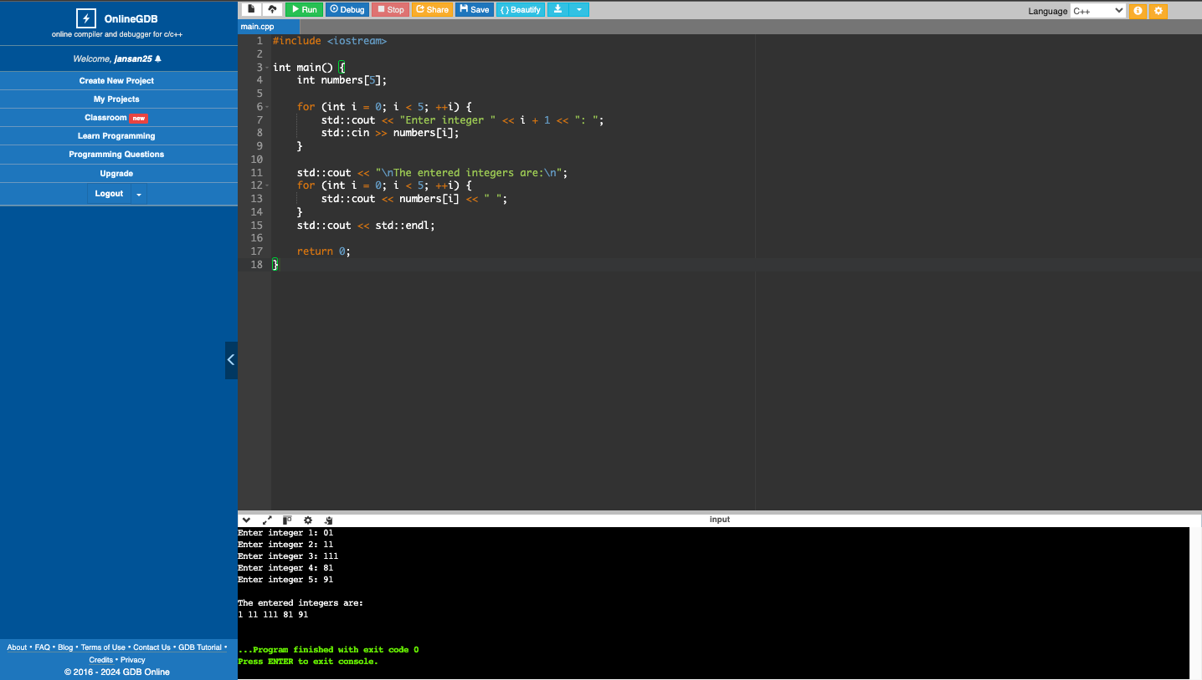

1. Write a program that will display an equilateral triangle with a height depending on the user. The minimum height is 1, the maximum height is 10. Use an array to display the specific character on the specific row. The array will be: { 0 := “A”, 1:= “B”, 2 := “C”, 3 := “D”, 4 := “E”, 5 := “F”, 6 := “G”, 7 := “H”, 8 := “I”, 9 := “J” }. You are limited to four (4) variables only (including the array).

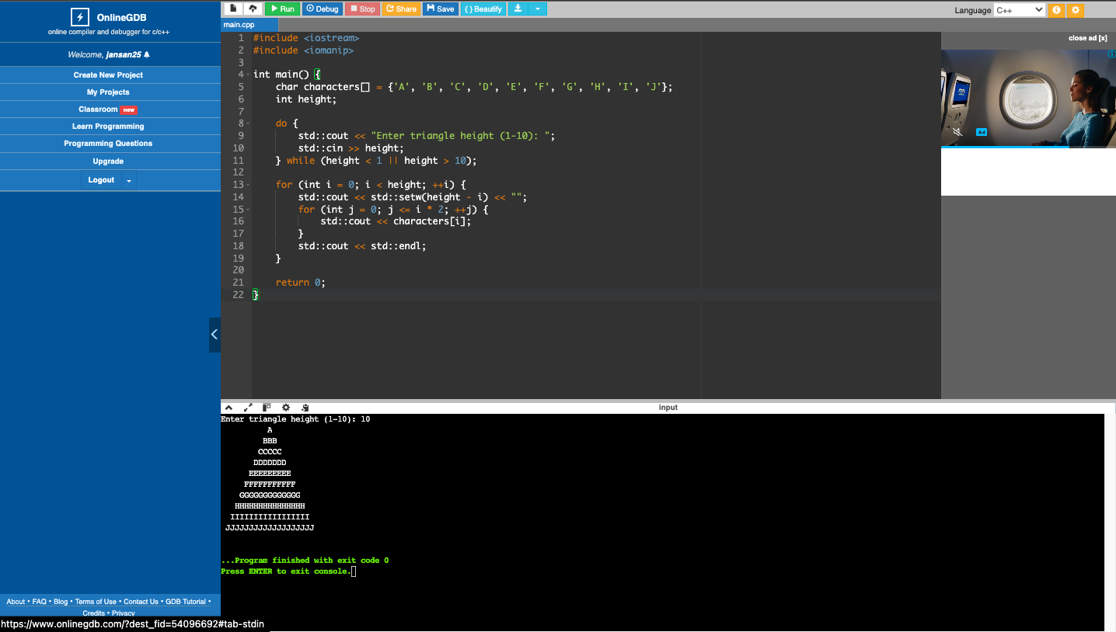

1. Write a program that will ascendingly sort six (6) integers from the user. Use only four (4) variables (including the array).

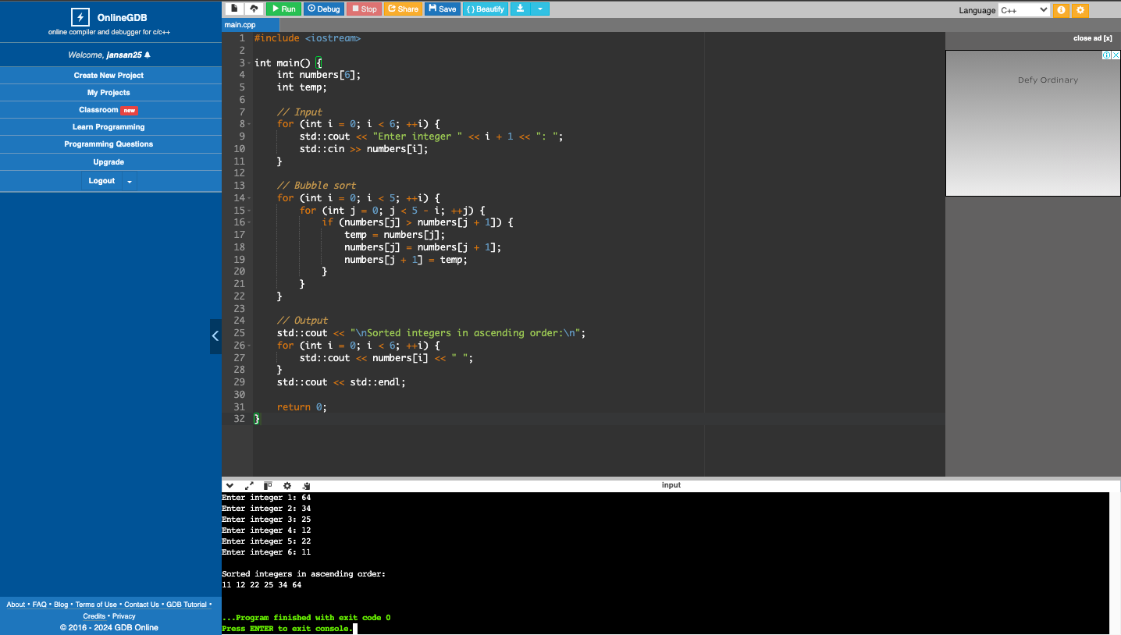

1. What can you conclude from this activity?

This activity taught me to solve problems using arrays, showing their efficiency for storing same-type data and their versatility in tasks like sorting.